**MA4605 Chemometrics Lab C**

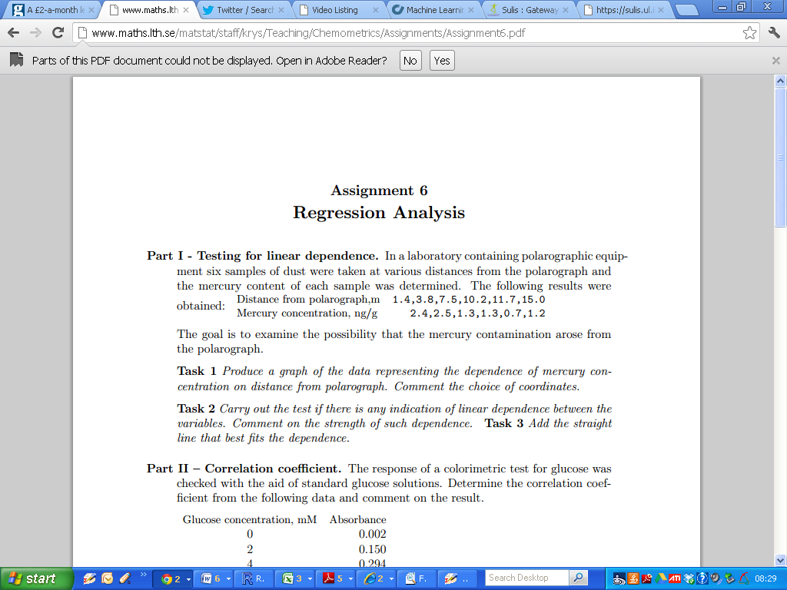

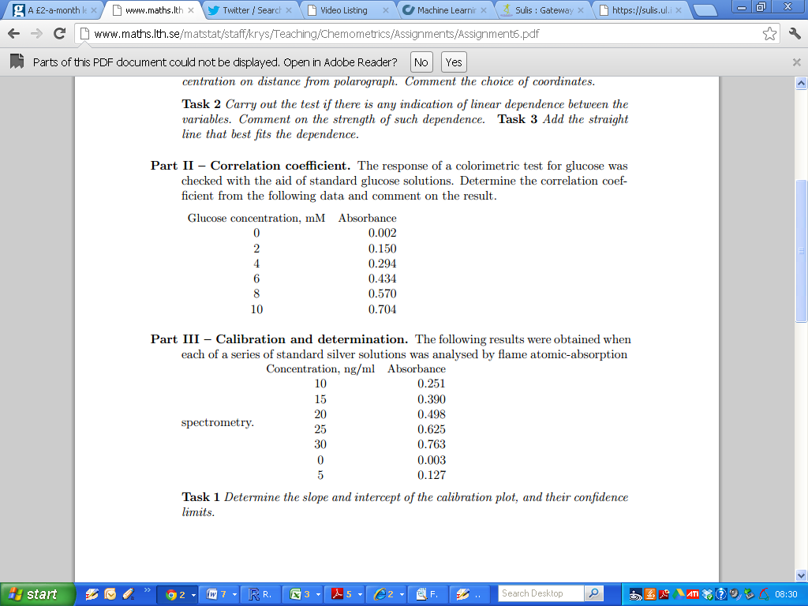

(Additional for 2012: What is the 95% confidence interval for the correlation coefficient)

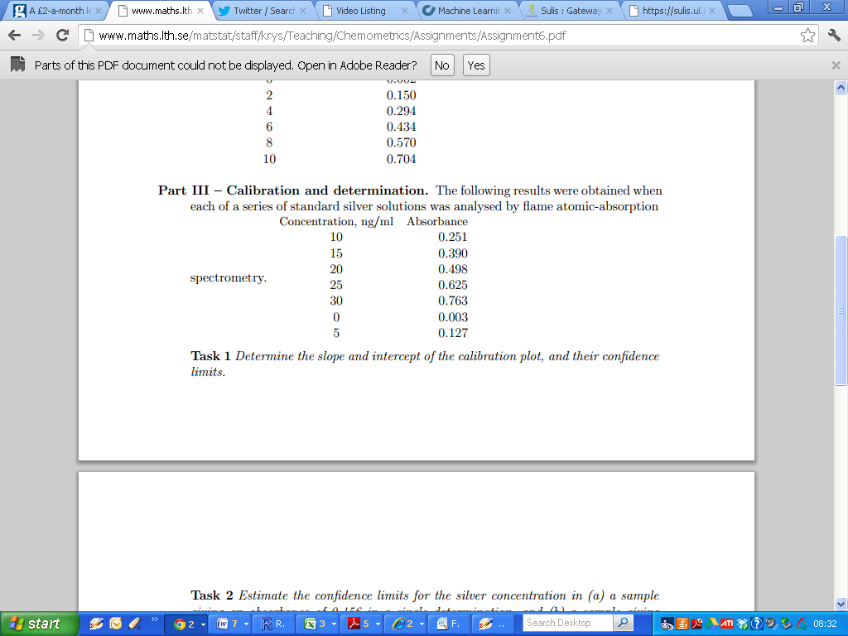

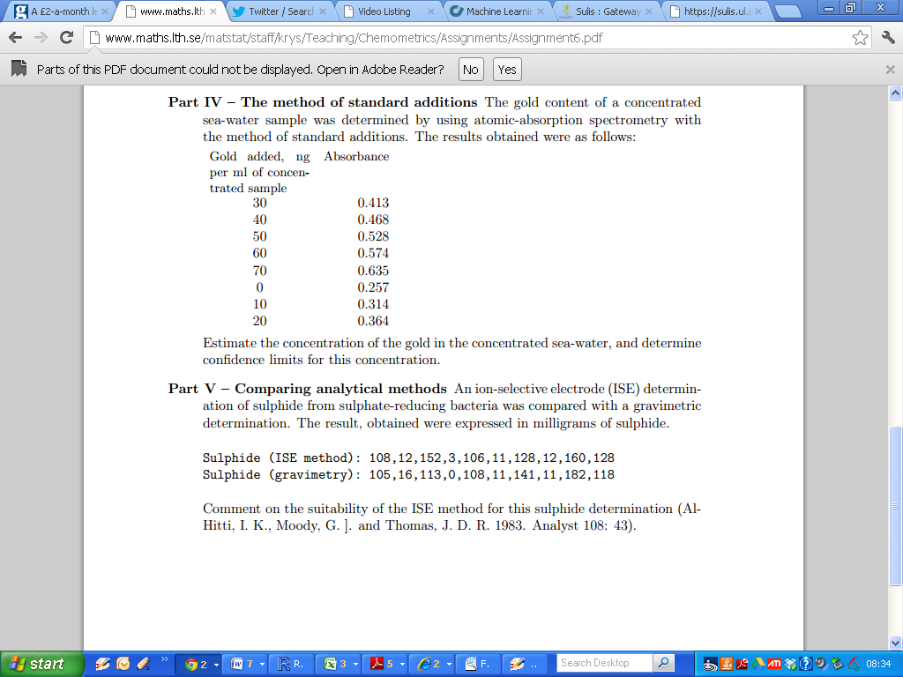

Determine the estimates for the slope and intercept. Additionally comment on the associated p-values from the summary output.

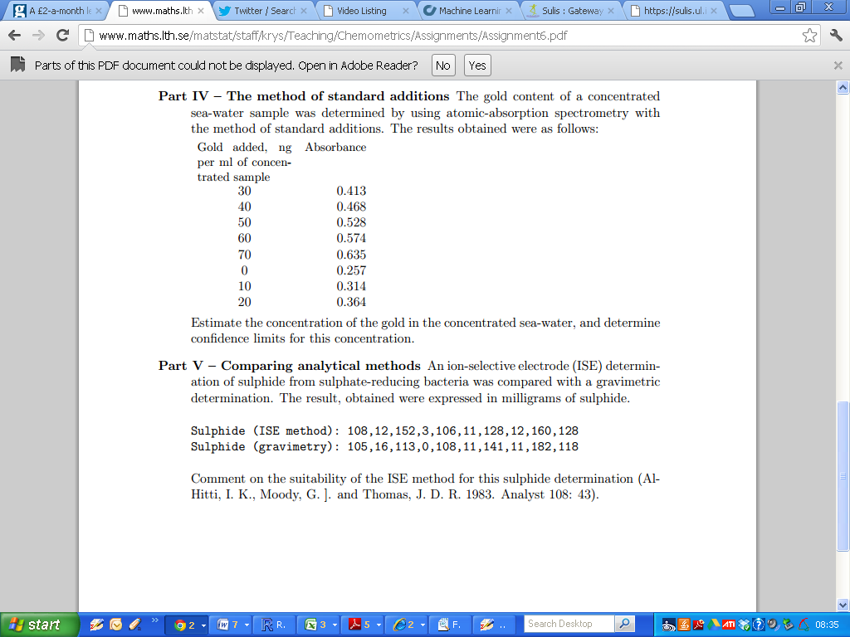

Compute the simple linear regression equation for the case where

1. The ISE method is the independent variable,
2. The ISE method is the dependent variable.

Write down the regression equations for both models.

Which approach (if any) is more suitable?